System Maintenance

System Overview
My system consists of 4 Units, of which 3 are forms allowing users to modify images and view information on how the algorithms for image manipulation work.
The main form shows two images the input and the output image as well as a menu bar with 4 tabs for loading and saving images, manipulating the images, manipulating the algorithms, and for viewing educational information. Using file/save or file/load opens up a windows explorer dialogue box sot that files can be browsed. The image tab has options for edge detection, red eye reduction, smoothing, noise reduction and greyscaling, where the algorithm is applied to the Input image on the left, and the result shown as the output image on the right. The tolerance tab has an option which will open up the secondary form for changing the tolerance of the red eye algorithm, and the info tab will open up the form displaying educational information about each algorithm. There are also left and right arrows at the bottom of the screen for setting the input image to the output image, or the output image to the input image respectively.
One of the secondary forms is used to edit the tolerance of the red eye reduction algorithm and consists of a slider which can be moved up and down to automatically change the number in a text box above it, which can be changed manually. When the set button is pressed the slider will change position to that indicated by the number if necessary and a preview of the colour tolerance will be displayed. If the value in the text box is an invalid input or out of the acceptable range an error message will be shown or the text box value will become the nearest in range value respectively. The Reset button reverts the tolerance to the default (144), and updates the slider and number as the set button would. The number in the text box represents the RED value of the RGB colour tolerance. The OK button sets the tolerance to the one chosen by the user, whilst the cancel button keeps the tolerance the same as it was before the form was opened. Both buttons also close the form.
The Info secondary form consists of 5 buttons and a large text box. There is one button for each of the 5 possible processes which can be carried out, with the greyscaling marked extension as this is not part of the Physics course but is relevant when using the edge detection algorithm. Pressing the buttons shows the corresponding information in the text box.
Unit 2 is the Unit in which all the code is contained for the actual processing of images, and the listings for functions and variables are provided later in the maintenance.

In the System the Units are broken up as such:
- UNIT 1 : The Main Form in which the images are displayed and user inputs are taken and processed
- UNIT 2 : The Unit with the code for all the image manipulation algorithms which actually edits the images. It also contains code for the Red Eye tolerance editing and stores some information for the Educational Tool
- UNIT 3 : The Form which handles inputs to the red eye tolerance editing
- UNIT 4: The Form which handles inputs and outputs for the Educational Tool
The most important part of the program is UNIT 2 which contains all the actual code for image editing. The Modular Structure of this part of the system is only subtly different from the original design. The Major Differences are:
- Time constraints led to Sobel Edge Detection being excluded
Image Processor +
Unit 1
(Main Form)
Unit 2
(Computation)
Unit 3 (Red
Eye Form)
Unit 4
(Educational)
Greyscale
Function
Negative
Function
Laplace
Function
Smoothing
Function
Red Eye
Function
Noise Removal
Function
Kernels
Apply Kernel
Function
Clear Image

Implementation Hierarchy Chart

GUI Implementation

Original Design

As was stated in the design, the system had to be user friendly, easy to navigate and relatively efficient to execute. As the system was implemented it became clear that certain changes to the GUI would need to be made in order to meet these aims, which I will discuss alongside the Implemented Forms.

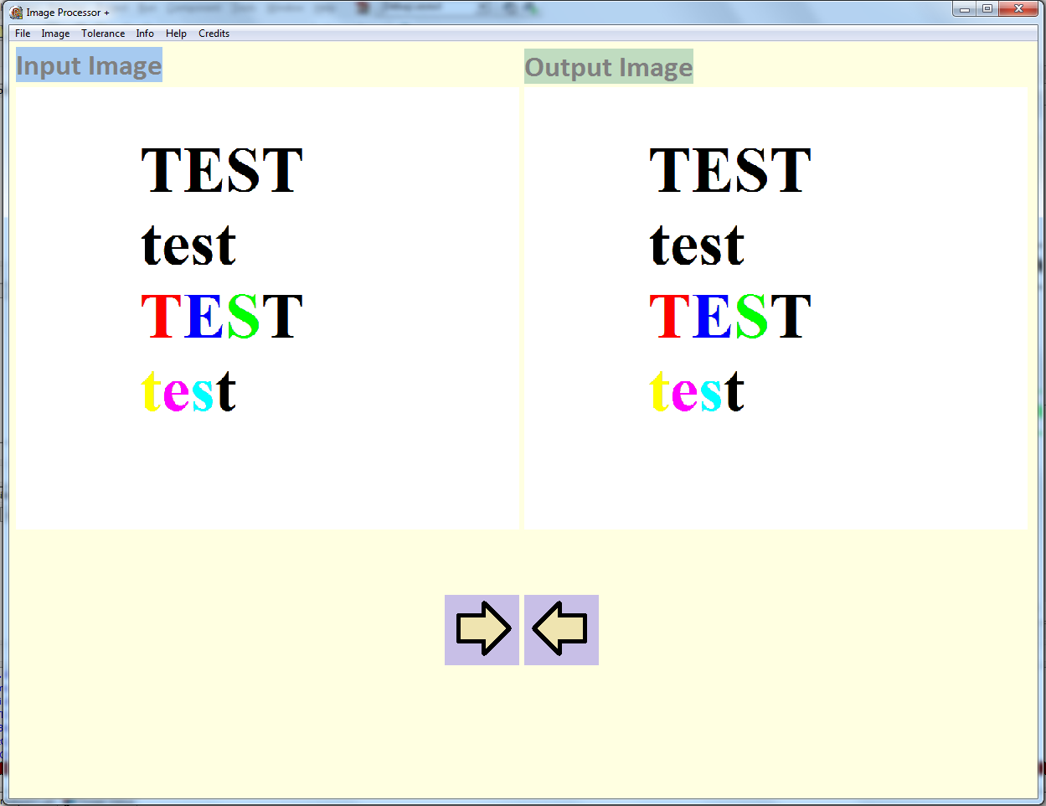
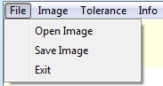
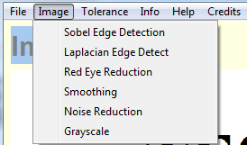
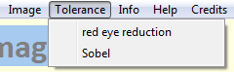

Implemented

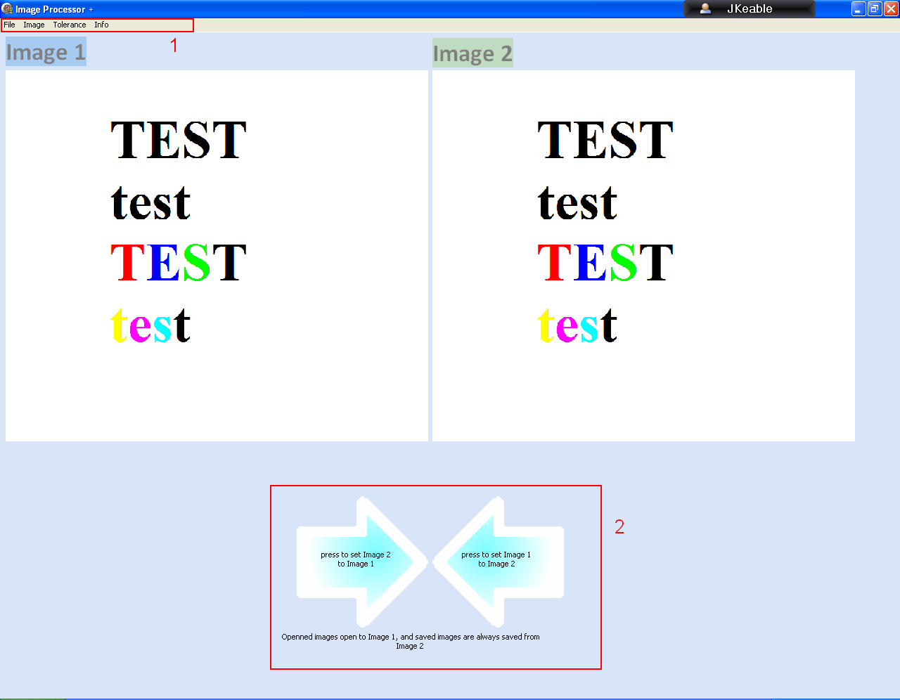

Changes
- Colour changed from Cream to blue to give higher contrast between elements on the form
- Arrows made larger and their purpose is explained more clearly in that they Set each Image to each other
- All reference to the Sobel algorithm are removed
- Menu entries for the Negative facility are added
- Credits removed as deemed unnecessary
- Help removed from program menu and moved to the User Manual
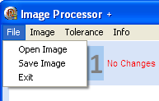
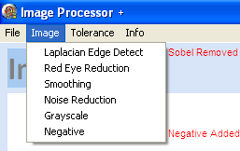
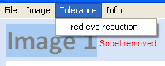
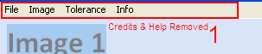
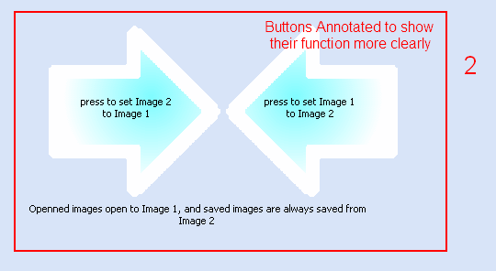

Detailed Algorithm Design
This section will relate the relevant algorithms to the coded procedures or functions.
n.b. in the pascal code ‘//TEXT’ means an in line comment whilst ‘{TEXT}’ and ‘(*TEXT*)’ mean a block comment

Pseudocode Algorithm | Pascal code
Procedure ApplyKernel  BEGINPROCEDURE  OutputImage ← InputImage  FOR i ← 1 TO ImagHeight DO  FOR i ← 1 TO ImagWidth DO  CASE  1: RGBImagePixel ← Laplace  2: RGBImagePIxel ← Smoothing  3: RGBImagePixel ← RedEye  4: RGBImagePIxe ← NoiseRemoval  5: RGBIMagePixel ← Grayscale  ENDPROCEDURE | procedure ApplyKernel(Width, Height: Integer; kernel : integer; Var Image1, Image2: TImage);  VAR  countw,counth : integer;  kernel3x3 : array [1..3,1..3] of integer;  count, count2: integer;  median : integer;  begin//procedure  Image2.Picture := Image1.Picture;  for counth := 1 to Height-2 do  for countw := 1 to Width - 2 do  begin//kernelTYPE  case {begin} kernel of  1:  begin //Laplace  Image2.Picture.Bitmap.Canvas.Pixels[countw, counth]  := Laplace(Image1,countw,counth)  end;//laplace  2:  begin //smoothing  Image2.Picture.Bitmap.Canvas.Pixels[countw, counth]  := smoothing(Image1,countw,counth);  end;//smoothing  3:  begin //red eye  //begin  image2.Picture.Bitmap.Canvas.Pixels[countw,counth]:=red_eye(Image1,countw,counth);  end;  4:  begin //Noise Removal  Image2.Picture.Bitmap.Canvas.Pixels[countw,counth] := Noise_removal(IMage1,countw,counth)  end;//Noise Removal  5:  begin //GrayScale  image2.Picture.Bitmap.Canvas.Pixels[countw,counth]:=Grayscale(image1.Picture.Bitmap.Canvas.Pixels[countw,counth])  end;//GrayScale  End;//case  end;//kerneltype  end;
Function Grayscale  BEGINFUNCTION  Red← RGBImagePIxel REDVALUE  Green ←RGBImagePixel GREENVALUE  Blue ←RGBImagePixel BLUEVALUE  Gray← 30% Red + 60% Green + 10% Blue  ResultRed ←Gray  ResultGreen ←Gray  ResultBlue←Gray  ENDFUNCTION | function grayscale(PixelColor:longint): integer;  var  Gray, Red, Green, Blue: Byte;{the RGB values for the original pixel and the  value to which they will all be set after the algorithm has been applied}  begin  Red := PixelColor;//red := to the first 8 bits of the rgb value  Green := PixelColor shr 8;//blue := to the second 8 bits of the rgb value  Blue := PixelColor shr 16;//green := to the third 8 bits of the rgb value  Gray := Round(0.3 * Red + 0.6 * Green + 0.1 * Blue);{0.3,0.6,and 0.1 are the  approximate values for how much of each type of colour make up gray }  Result := RGB(Gray, Gray, Gray);  end;
Function RedEye  BEGINFUNCTION  RedTolerance ← RedToleranceTextBox  GreenBlueTolerance ←255 – RedTolerance  Red ← RGBImagePIxel REDVALUE  Green← RGBImagePixel GREENVALUE  Blue ← RGBImagePixel BLUEVALUE  If (Red >RedTolerance)  AND (Green<GreenBlueTolerance)  AND (Blue<GreenBlueTolerance)  THEN result ← Grey  ELSE Result ← RGBImagePixel  ENDFUNCTION | function red_eye(Image:Timage;x,y:integer):integer;  Var  Red,Green,Blue :Byte;  redtolerance, gbtolerance :integer;  begin  try redtolerance := strtoint(unit3.Form1.memo1.text);  except  begin  showmessage('ERROR: red tolerance invalid');  redtolerance := 144  end;  end;  gbtolerance := 255-redtolerance;  Red := image.Picture.Bitmap.Canvas.Pixels[x,y] shr 0;  Green := image.Picture.Bitmap.Canvas.Pixels[x,y] shr 8;  Blue := image.Picture.Bitmap.Canvas.Pixels[x,y] shr 16;  if (Red > redtolerance) and((Green < gbtolerance) and (Blue < gbtolerance))  then red_eye := strtoint('$'+'777777')  else result:=image.Picture.Bitmap.Canvas.Pixels[x,y]  end;//red eye
Function NoiseRemoval  Function GetMedian  BEGINUNCTION  REPEAT  swapped false  FOR i ← 0 TO length(list) - 2 DO  IF list[i-1] > list[i] THEN  swap( list[i-1], list[i] )  swapped ← true  ENDIF  ENDFOR  UNTIL NOT swapped  Result ← list[4]  ENDFUNCTION  BEGINFUNCTION  SomeArray[1] ←RGBImagePixelCentre,  SomeArray[2] ← RGBImagePixelTop SomeArray[3] ← RGBImagePixelBottom  SomeArray[4] ← RGBImagePixelTopright  SomeArray[5] ← RGbImagePixelBottomright  SomeArray[6] ← RGBImagePixelTopleft  SomeArray[7] ← RGBImagePixelBottomLeft  SomeArray[8] ← RGBImagePixelRight  SomeArray[9] ← RGBImagePixelLeft  Result≔GetMedian(SomeArray)  ENDFUNCTION | function noise_removal(Image:Timage;x,y:integer):integer;  function bubblesortMEDIAN (list : array of integer):integer;  Var  swapped: boolean;  i,temp: integer;  begin  repeat  swapped := false;  for i := 0 to 7 do  if list[i-1] > list[i]then  begin  temp:= list[i];  list[i] := list[i-1];  list[i-1] := temp;  swapped := true  end  until not swapped;  Result := list[4]  end;//bubblesortmean  Var  UnSortedArray: array [1..9] of integer;  begin  UnsortedArray[1] := Image.Picture.Bitmap.canvas.pixels[x,y];  UnsortedArray[2] := Image.Picture.Bitmap.canvas.pixels[x,y+1];  UnsortedArray[3] := Image.Picture.Bitmap.canvas.pixels[x,y-1];  UnsortedArray[4] := Image.Picture.Bitmap.canvas.pixels[x+1,y+1];  UnsortedArray[5] := Image.Picture.Bitmap.canvas.pixels[x+1,y-1];  UnsortedArray[6] := Image.Picture.Bitmap.canvas.pixels[x-1,y+1];  UnsortedArray[7] := Image.Picture.Bitmap.canvas.pixels[x-1,y-1];  UnsortedArray[8] := Image.Picture.Bitmap.canvas.pixels[x+1,y];  UnsortedArray[9] := Image.Picture.Bitmap.canvas.pixels[x-1,y];  //then sort  result := bubblesortmedian(unsortedarray)  end;//noiseremoval
Function Smoothing  BEGINFUNCTION  SumRed←0  SumGreen←0  SumBlue←0  SomeArrayRed[1] ←RGBImagePixelCentre RED,  SomeArrayRed[2] ← RGBImagePixelTop RED  SomeArrayRed[3] ← RGBImagePixelBottom RED  SomeArrayRed[4] ← RGBImagePixelTopright RED  SomeArrayRed[5] ← RGbImagePixelBottomright RED  SomeArrayRed[6] ← RGBImagePixelTopleft RED  SomeArrayRed[7] ← RGBImagePixelBottomLeft RED  SomeArrayRed[8] ← RGBImagePixelRight RED  SomeArrayRed[9] ← RGBImagePixelLeft RED  FOR i ← 1 to 9 do SumRed ← SumRed + SomeArrayRed[i]  ENDFOR  Red ← SumRed DIV 9  SomeArrayGreen[1] ←RGBImagePixelCentre GREEN,  SomeArrayGreen[2] ← RGBImagePixelTop GREEN  SomeArrayGreen[3] ← RGBImagePixelBottom GREEN  SomeArrayGreen[4] ← RGBImagePixelTopright GREEN  SomeArrayGreen[5] ← RGbImagePixelBottomright GREEN  SomeArrayGreen[6] ← RGBImagePixelTopleft GREEN  SomeArrayGreen[7] ← RGBImagePixelBottomLeft GREEN  SomeArrayGreen[8] ← RGBImagePixelRight GREEN  SomeArrayGreen[9] ← RGBImagePixelLeft GREEN  FOR i ← 1 to 9 do SumGreen ← SumGreen + SomeArrayGreen[i]  ENDFOR  Green ← SumGreen DIV 9  SomeArrayBlue[1] ←RGBImagePixelCentre BLUE,  SomeArrayBlue[2] ← RGBImagePixelTop BLUE  SomeArrayBlue[3] ← RGBImagePixelBottom BLUE  SomeArrayBlue[4] ← RGBImagePixelTopright BLUE  SomeArrayBlue[5] ← RGbImagePixelBottomright BLUE  SomeArrayBlue[6] ← RGBImagePixelTopleft BLUE  SomeArrayBlue[7] ← RGBImagePixelBottomLeft BLUE  SomeArrayBlue[8] ← RGBImagePixelRight BLUE  SomeArrayBlue[9] ← RGBImagePixelLeft BLUE  FOR i ← 1 to 9 do SumBlue ← SumBlue + SomeArrayBlue[i]  ENDFOR  Blue ← SumBlue DIV 9  ResultRed ←Red  ResultGreen←Green  ResultBlue←Blue | function smoothing(Image:Timage;x,y:integer):integer;  var  red,blue,green :byte;  count, sumr, sumg, sumb : integer;  kernelR, kernelg, kernelb : array [1..9] of byte;  begin  sumr := 0;  sumg := 0;  sumb := 0;  kernelR[1]:=Image.Picture.Bitmap.canvas.pixels[x,y];  kernelR[2]:=Image.Picture.Bitmap.canvas.pixels[x+1,y];  kernelR[3]:=Image.Picture.Bitmap.canvas.pixels[x,y+1];  kernelR[4]:=Image.Picture.Bitmap.canvas.pixels[x+1,y+1];  kernelR[5]:=Image.Picture.Bitmap.canvas.pixels[x-1,y];  kernelR[6]:=Image.Picture.Bitmap.canvas.pixels[x,y-1];  kernelR[7]:=Image.Picture.Bitmap.canvas.pixels[x-1,y-1];  kernelR[8]:=Image.Picture.Bitmap.canvas.pixels[x-1,y+1];  kernelR[9]:=Image.Picture.Bitmap.canvas.pixels[x+1,y-1];  for count := 1 to 9 do  begin  sumr := sumr + kernelR[count]  end;  Red := sumr div 9;//smoothred  kernelg[1]:=Image.Picture.Bitmap.canvas.pixels[x,y]shr 8;  kernelg[2]:=Image.Picture.Bitmap.canvas.pixels[x+1,y]shr 8;  kernelg[3]:=Image.Picture.Bitmap.canvas.pixels[x,y+1]shr 8;  kernelg[4]:=Image.Picture.Bitmap.canvas.pixels[x+1,y+1]shr 8;  kernelg[5]:=Image.Picture.Bitmap.canvas.pixels[x-1,y]shr 8;  kernelg[6]:=Image.Picture.Bitmap.canvas.pixels[x,y-1]shr 8;  kernelg[7]:=Image.Picture.Bitmap.canvas.pixels[x-1,y-1]shr 8;  kernelg[8]:=Image.Picture.Bitmap.canvas.pixels[x-1,y+1]shr 8;  kernelg[9]:=Image.Picture.Bitmap.canvas.pixels[x+1,y-1]shr 8;  for count := 1 to 9 do  begin  sumg := sumg + kernelg[count]  end;  green := sumg div 9;//smoothgreen  kernelb[1]:=Image.Picture.Bitmap.canvas.pixels[x,y]shr 16;  kernelb[2]:=Image.Picture.Bitmap.canvas.pixels[x+1,y]shr 16;  kernelb[3]:=Image.Picture.Bitmap.canvas.pixels[x,y+1]shr 16;  kernelb[4]:=Image.Picture.Bitmap.canvas.pixels[x+1,y+1]shr 16;  kernelb[5]:=Image.Picture.Bitmap.canvas.pixels[x-1,y]shr 16;  kernelb[6]:=Image.Picture.Bitmap.canvas.pixels[x,y-1]shr 16;  kernelb[7]:=Image.Picture.Bitmap.canvas.pixels[x-1,y-1]shr 16;  kernelb[8]:=Image.Picture.Bitmap.canvas.pixels[x-1,y+1]shr 16;  kernelb[9]:=Image.Picture.Bitmap.canvas.pixels[x+1,y-1]shr 16;  for count := 1 to 9 do  begin  sumb := sumb + kernelb[count]  end;  blue := sumb div 9;//smoothblue  result := RGB(red,green,blue);//smoothcolour  end;  ENDFUNCTION
ON BUTTON ‘GrayScale’ CLICK  DO ApplyKernel(Grayscale) | procedure TForm2.Grayscale1Click(Sender: TObject);  begin  ApplyKernel(Image1.Picture.Bitmap.Width, Image1.picture.Bitmap.Height,5, Image1, Image2)  end;
ON BUTTON ‘RedEyeTolerance’ CLICK  DO VIEW RedToleranceForm  ON RedToleranceForm BUTTON ‘OK’ click  DO OldTolerance ← NewTolerance FROM RedToleranceForm | procedure TForm2.redeyereduction2Click(Sender: TObject);  begin  unit3.Form1.Visible := true;  unit3.Form1.Button1Click(Sender);  unit3.oldtolerance := strtoint(unit3.Form1.Memo1.text)  end;
ON BUTTON ‘SET’ CLICK  ScrollBar1Pos ← TextBox  PreviewImageRED←TextBox  PreviewImageGREEN←255 – TextBox  PreviewImageBLUE←255 – TextBox | procedure TForm1.Button1Click(Sender: TObject);  var x,y : integer;  begin  if Memo1.text <> '' then  Begin  Try ScrollBar1.Position := strtoint(memo1.Text)  Except  ShowMessage('Invalid Input');  End;  Try  for y := 0 to Image1.height do  for x := 0 to Image1.width do  image1.Picture.Bitmap.Canvas.Pixels[x,y]  := RGB(strtoint(memo1.Text),255-strtoint(Form1.memo1.text),255-strtoint(Form1.memo1.text)) Except  showmessage('ERROR: unknown')  End  End;

Annotated Listings

Procedures/Functions

Unit2
function grayscale(PixelColor:longint): integer;
transforms a single pixel to gray, where PixelColour contains Red,Green and Blue values which can be separated by msb.
function Laplace(Image:Timage;x,y:integer):integer;
applies the Laplacian Edge Detection algorithm to a 3x3 kernel based on a central pixel
function smoothing(Image:Timage;x,y:integer):integer;
applies the smoothing algorithm to a 3x3 kernel based on a central pixel
function red_eye(Image:Timage;x,y:integer):integer;
checks to see if a single pixel is ‘red’ based on a tolerance and if the pixel is red will transform it to a medium shade of grey
function noise_removal(Image:Timage;x,y:integer):integer;
will apply the noise reduction algorithm to a 3x3 kernel based on a central pixel
function bubblesortMEDIAN (list : array of integer):integer;
a subfunction of ‘noise_removal’ which bubble sorts the kernel then finds the median value once passed the kernel by the parent function
function ClearImage(Image:TImage):TImage;
clears a specified image to white
procedure ApplyKernel(Width, Height: Integer; kernel : integer; Var Image1, Image2: TImage);
Is initialized by a button click which also gives it the algorithm to apply, and the function then steps through each pixel of the image (except the outer 1 pixel border as a 3x3 kernel cannot be applied to these pixels) and calls the specified algorithm which will apply itself to each pixel and pass back the new value for each pixel. This procedure then sets each output image pixel to the result from the called function as it steps through the pixels.
procedure TForm2.Grayscale1Click(Sender: TObject);
initializes the AppyKernel Procedure with the grayscale function
procedure TForm2.Image3Click(Sender: TObject);
sets input image to output image
procedure TForm2.Image5Click(Sender: TObject);
sets input image to output image
procedure TForm2.Info1Click(Sender: TObject);
makes the educational information form visible
procedure TForm2.Laplacianedgedetect1Click(Sender: TObject);
initializes the AppyKernel Procedure with the Laplace function
procedure TForm2.Load1Click(Sender: TObject);
opens a windows dialogue box for opening image files
procedure TForm2.NoiseReduction1Click(Sender: TObject);
initializes the AppyKernel Procedure with the noise_reduction function
procedure TForm2.RedEyeReduction1Click(Sender: TObject);
initializes the AppyKernel Procedure with the red_eye function
procedure TForm2.redeyereduction2Click(Sender: TObject);
makes the red eye reduction tolerance editor form visible allowing the user to edit the tolerance
procedure TForm2.Smoothing1Click(Sender: TObject);
initializes the AppyKernel Procedure with the smoothing function
procedure TForm2.SaveImage1Click(Sender: TObject);
opens a windows dialogue box for saving image files

Unit3
procedure TForm1.Button1Click(Sender: TObject);
sets the scrollbars value to the value in the text box if possible, and sets the color of the preview image to the tolerance indicated by that number
procedure TForm1.Button2Click(Sender: TObject);
sets the tolerance to the one selected by the user, and hides the tolerance editor form
procedure TForm1.Button3Click(Sender: TObject);
cancels the change to the tolerance, so the old tolerance is kept, and hides the tolerance editor form
procedure TForm1.Button4Click(Sender: TObject);
resets the text box value in the tolerance editor to ‘144’, and has the same effect as the ‘SET’ button click afterward
procedure TForm1.FormCreate(Sender: TObject);
creates the redtolerance editor form
procedure TForm1.ScrollBar1Change(Sender: TObject);
sets the text box value to that indicated by the scroll bar when it is moved

Unit4
function assigninfo(code:char):string;
gets the educational text from text files so that it can later be placed in the form
function getinfo(code:char):string;
using the assigninfo function this actually places text in the text boxes on the form

Constants/Variables

Unit2

Variables
Identifier | Type | Description
Red | Byte | An 8 bit value used in the Grayscale function to store the Red part of the colour of a pixel
Blue | Byte | An 8 bit value used in the Grayscale function to store the Blue part of the colour of a pixel
Green | Byte | An 8 bit value used in the Grayscale function to store the Green part of the colour of a pixel
Gray | Byte | An 8 bit value used in the Grayscale function to store the gray value calculated from a catenation of the three RGB values of a pixel
Red | Byte | An 8 bit value used in the Negative function to store the Red part of the colour of a pixel
Blue | Byte | An 8 bit value used in the Negative function to store the Blue part of the colour of a pixel
Green | Byte | An 8 bit value used in the Negative function to store the Green part of the colour of a pixel
Red | Byte | An 8 bit value used in the Smoothing function to store the Red part of the colour of a pixel
Blue | Byte | An 8 bit value used in the Smoothing function to store the Blue part of the colour of a pixel
Green | Byte | An 8 bit value used in the Smoothing function to store the Green part of the colour of a pixel
count | Integer | An Integer used by the smoothing function to add up the numbers in the array kernel
sumr | Integer | An Integer used by the smoothing function as the sum of the 9 red values for the pixels in the 3x3 kernel
sumb | Integer | An Integer used by the smoothing function as the sum of the 9 blue values for the pixels in the 3x3 kernel
sumg | Integer | An Integer used by the smoothing function as the sum of the 9 green values for the pixels in the 3x3 kernel
kernelR | Array[1…9] of Integer | An array to store the 9 Red values for the pixel kernel in the smoothing function
kernelG | Array[1…9] of Integer | An array to store the 9 Green values for the pixel kernel in the smoothing function
kernelB | Array[1…9] of Integer | An array to store the 9 Blue values for the pixel kernel in the smoothing function
Red | Byte | An 8 bit value used in the Red_eye function to store the Red part of the colour of a pixel
Blue | Byte | An 8 bit value used in the Red_eye function to store the Blue part of the colour of a pixel
Green | Byte | An 8 bit value used in the Red_eye function to store the Green part of the colour of a pixel
redtolerance | integer | A value used by the red_eye function to test whether or not the red RGB value of a pixel is large enough for it to be red
gbtolerance | integer | A value used by the red_eye function to test whether or not the green and blue RGB values for a pixel are small enough for it to be considered red
count | integer | An integer used by the BubbleSortMEAN function to bubblesort the kernel of RGB values
Count2 | integer | An integer used by the BubbleSortMEAN function to bubblesort the kernel of RGB values
temp | Integer | An integer used by the BubbleSortMEAN function to bubblesort the kernel of RGB values to store temporary values when swapping values in the list
UnSortedArray | Array[1..9] | The kerenel in array form used by the NoiseReduction used to find the median
countw | Integer | Used by ApplyKernel to step through the rows of pixels
counth | integer | Used by ApplyKernel to step through the columns of pixels

